**COMP 3059 – Capstone Project I**

**Software Requirements Analysis and Design Assignment**

# 1.0 Introduction

## Purpose

This project is to establish a presence for JC Consulting. The goal is to establish a web presence that will allow JC Consulting to have their operations run online. This will enable them to broaden their operations and clients, both companies looking to hire new employees and potential workers looking for said jobs. The current aim is to allow for both sides of the firm’s interests to create their own online profile and then be matched by JC Consulting in an easy and straightforward manner.

## Scope

This software system will be a Web Consulting System for both companies who are looking to hire new employees that fit with requirements and potential workers who are seeking for a job as demand. This system will be designed to maximize the job consulting by providing tools to assist in automating select suitable candidates for the positions, which would otherwise have to be performed manually. By maximizing the system’s work efficiency and production, the system will meet both sides client and candidate while remaining easy to understand and use.

More specifically, the system is designed to have a responsive and friendly GUI for each side. It contains the AUTH mechanism that only owner of an account with a right permission can log in. Both sides have a functionality which creating resumes or job description. Besides, the system will supply essential features such as analyzing, filtering, ranking, flagging and tagging that can facilitate the matching between employers and candidates. The system also contains a relational database containing a list of Client, Candidate and Jobs Description.

The current stage will not include the AI or machine learning which can help to enhance the functionality of the system. These advanced technologies will be developed in the next stage.

# System Overview

Generally, candidate users and employer users will be provided necessary tools and information via JC consulting after their inputs to the web-app. Results will be lists of potential employees for the jobs or lists of companies are looking for candidates with detail information and links to both end-users. There will be also administrator with the main responsibility is to supervise users’ activities.

## Project Perspective

Everyone can use JC consulting as it is developed for job-seekers and employers. Users can upload their resumes as well as post job advertisements and JC acts as an intermedia between 2 end-users and matches them together. JC provides variety range of tools and functionalities to help users find suitable jobs and support many types of documents in terms of formatting.

It is, at the beginning, developed to be a web application. Possibly be able to run on mobile platform but it is considered out of scope for this project. Further enhancement will be applied during the processes if the web app meets all the basic requirements.

The lists of candidates generated by JC consulting will be sent back to the partner companies with the general information included:

* Candidate’s name and general information
* Link to candidate’s account
* Skills they have that matched the job description
* Email, linkedIn account

## System Context

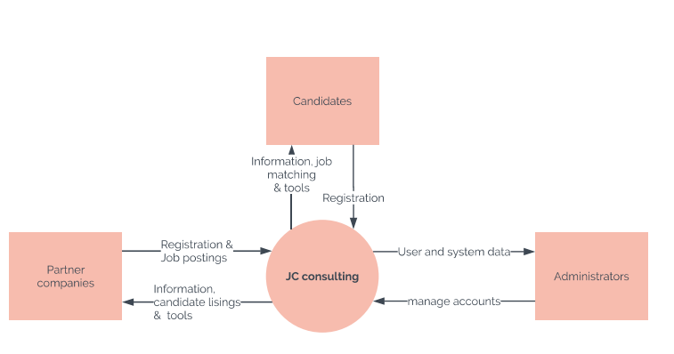

There should be 3 users for JC consulting system: candidates, who has to register account in order to receive the tools and needed information. Partner companies has the same privileges as candidates and they can post job advertisement and get lists of suitable candidates from JC as well as their detailed information. Administrators are who supervise user’s activities, examining and fixing any potential issues occurred on server-side or client-side.

## General Constraints

JC consulting will be developed using several web languages like HTML, CSS, TypeScript, Angular... and non-relational database like MongoDB. There will be external packages used for building, maintaining and testing the web-app. These constraints included:

* + Technologies to implement the additional features that are considered out of scope
  + Abstract concepts and definitions need to be clarified and understood fully
  + Point to connect both team’s parts together after all parts are completed
  + Input, mock-up database used in testing phases
  + Documents formatting limitation
  + Resolving problems and adapting regard of new updates in technologies that completely affect most of the project

## Assumptions and Dependencies

So far, JC consulting is a web application so it will be deployed on server.

**Assumptions**:

* The web-app will be deployed successfully on localhost before deploying on any domain
* Any updates in technologies will affect the projects
* Team members understand requirements and concepts fully before getting into building web-app.
* Both teams whom are working on JC will agree on the technologies that will be used for JC consulting
* Both teams will be working on the same Database technology which is MongoDB
* Both teams should be using the same version of technologies which will be decided from the get-go
* Basic requirements and features are top priority before any additional feature is added
* Main objective for the web-app is that it will be able to run on any browser in window mode. (Mobile mode will be out-of-scope feature)
* Environment should be installed successfully on developer’s system

**Dependencies**:

* TypeScript 3.1.6 or newer
* Angular and Nodejs 8.x or 10.x
* MongoDB (non-relational database)
* IE (Internet Explore) 8.0 or higher
* External resources agreed during the setting up phase.

## 3.0 Functional Requirements

This section describes specific features of the software project. If desired, some requirements may be specified in the use-case format and listed in the Use Cases Section.

### 3.1 Functional Requirements

* Introduction
  1. Contractors will need to register for a profile.
  2. Having registered, contractors will need to log in using information provided during registration.
  3. Contractors will submit their resume/fill out an applicant profile
  4. Contractors may submit their interest in positions posted to JC consulting and will be made aware if they were matched or rejected for said jobs.
  5. Contractors will be made aware if they were matched with jobs and may accept or reject the offer.
* Inputs
  1. Contractor registration information (username, password, email, etc.)
  2. Contractor login information (username, password)
  3. Applicant profile/resume information (work experience, skills, etc.)
  4. Job applications
  5. Applicant item (based off of Applicant profile information)
  6. Skills
* Processing
  1. Registration will add contractor to system.
  2. Login will validate the contractor to use the rest of the system.
  3. Adding applicant information will either create or update application item in system.
  4. Applying for specific job will keep contractor aware of its status
  5. Matching application will match details in applicant item with requirements for specific jobs.
* Outputs
  1. Initial set up user account on registration
  2. Login verification
  3. Applicant profile/item
  4. Job matches
  5. Job offers/rejections

...

## 3.2 Use Cases

**3.2.1 Use Case #1**

The Contractor registers for the site. Before this case can be initiated, the Contractor has already accessed the JC Consulting Website and selected the option to register as a contractor.

* 1. The Contractor fills out their basic user information, including their name, address, email, phone number, and password, and submits the information.
  2. The system checks to make sure the information is all added and valid and presents confirmation to the Contractor if so through an email validation.
  3. The Contractor confirms the registration through their email.
  4. The system adds the Contractor to the database.

**3.2.2 Use Case #2**

The Contractor logs into the system. Before this case can be initiated, the Contractor has already accessed the JC Consulting Website and is registered in the database as a user.

* 1. The Contractor enters their username and password.
  2. The system verifies that the entered information is correct, and if so it logs the Contractor into the main site and directs them to their profile.

**3.2.3.1 Use Case #3.1**

The Contractor submits their resume/applicant information to build their profile to find a job. Before this can be initiated, the Contractor has already accessed the JC Consulting Website and is logged in.

* 1. The Contractor, if desired, submits a resume document to the system.
  2. The system takes any submitted document and, according to standard resume practices, autocompletes any applicable information on the applicant form.
  3. The Contractor verifies any autocompleted information and adds any other information as necessary before submitting the form.
  4. The system checks to make sure the information is added and presents a summary of the submitted information to the Contractor.
  5. The Contractor confirms the information.
  6. The system adds the information to the database and directs the Contractor to their finished profile.

**3.2.3.2 Use Case #3.2**

The Contractor edits their applicant information to enhance or change their profile. Before this can be initiated, the Contractor has already accessed the JC Consulting Website, is logged in, and has already completed their initial applicant information submission.

* 1. The Contractor selects the part of the form they wish to change.
  2. The system directs them to a form for the selected part.
  3. The Contractor adds, removes, or edits information as necessary and submits it.
  4. The system presents a summary of the changes to the Contractor.
  5. The Contractor confirms the changes.
  6. The system alters the information in the database and directs the Contractor to their finished profile.

**3.2.2 Use Case #4**

The Contractor finds a job they are interested in, and apply for it to show their interest in the position. Before this can be initiated, the Contractor has already accessed the JC Consulting Website and is logged in.

* 1. The Contractor initiates a job search, optionally with specific terms (ie: position, company name, or skills required).
  2. The system returns a list of positions.
  3. The Contractor selects the desired one.
  4. The system gives a more detailed overview of the position and its requirements.
  5. The Contractor chooses whether or not they wish to apply for the position specifically.

**3.2.3 Use Case #5**

A Contractor is being matched with a potential job put forward by a Client (a.k.a. a company), and are informed of the result. Before this can be initiated, the Contractor has already completed their applicant information submission.

* 1. A Client job position is set to be matched with a Contractor.
  2. The system goes over the best matches amongst the Contractors within the database and sends them to JC Consulting.
  3. JC Consulting selects the best Contractors manually, and submits them to the system.
  4. The system checks if a Contractor stated interest in the job position.
  5. Matching:
     1. If the Contractor is not matched to the job position but stated interest in it, the system informs them they were not selected. If they did not state interest they are not informed.
     2. If the Contractor is matched to the job position, the system makes them aware of the match.
  6. The Contractor, if matched, may choose to opt out of the position if they are not interested, and the system will find another candidate.
  7. The Contractor will then, potentially, be independently contacted by the Client who put forward the job position.
  8. If chosen amongst the selected matches by the Client, the Contractor will be informed by the system that they were hired.

**3.3 Data Modelling and Analysis**

* Normalized Data Model Diagram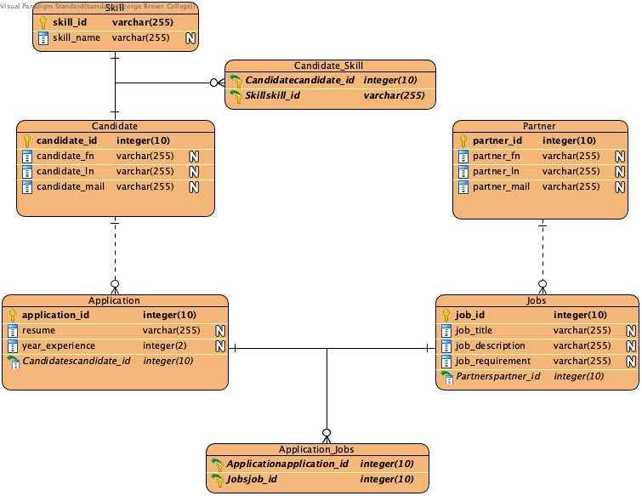
* Activity Diagrams

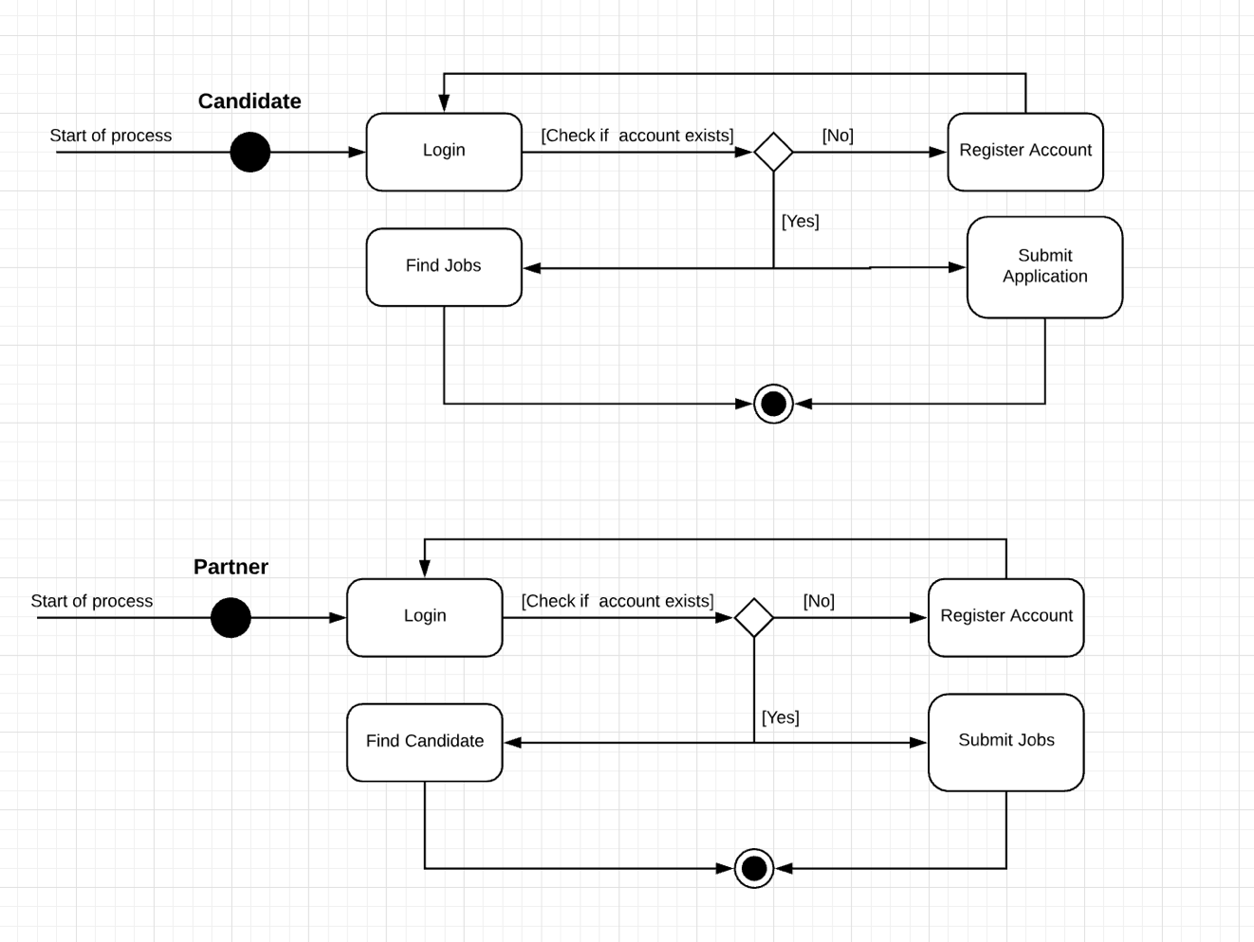

* Sequence Diagrams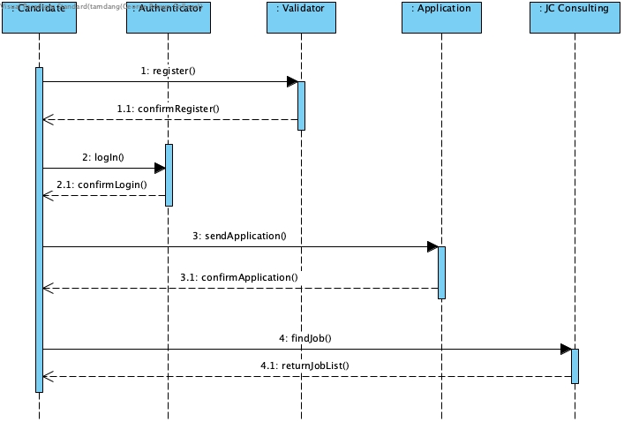
* UML Class Diagram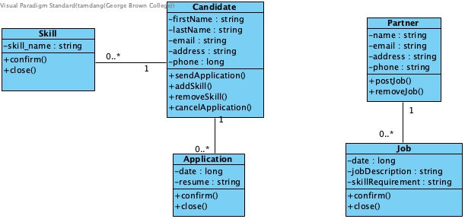

**3.4 Process Modelling**

* Data Flow Diagram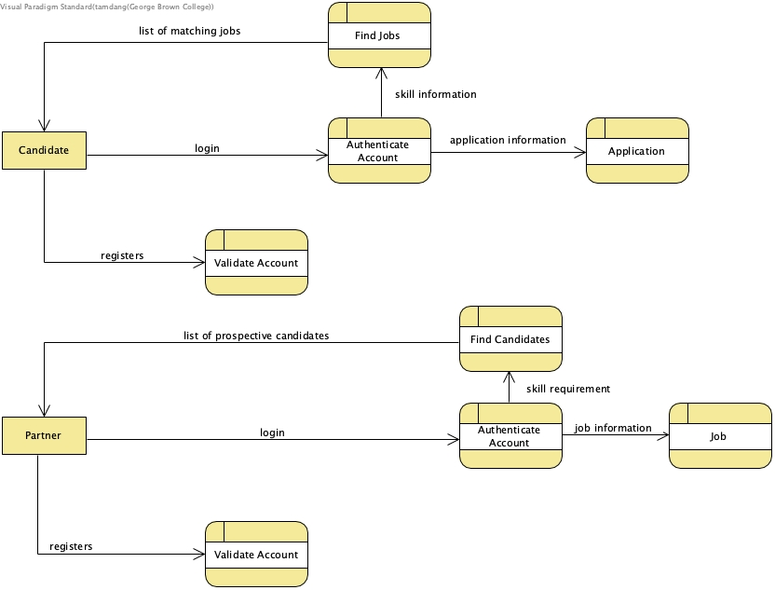

## 4.0 Non-Functional Requirements

Performance: All functions, transitions, and applications the program runs must be performed in a limited time. With the exception of database searches and the matching function, all other operations run on an optimal machine with a solid internet connection should run within a second. The other two functions should run within ten seconds.

Reliability: The application must run without any errors or crashes, and only present accurate and up to date information. Any changes must register to all users as soon as the change occurs to prevent potential misinformation.

Availability: The application must be available to users at any time and in any place that has an internet connection. It must be available on personal computers or similar machines (not mobile devices).

Security: The application must be relatively secure, as it stores personal/corporate information as well as information on job offers that companies might want to leave to JC Consulting alone. It does not store vital details such as credit card or social security information so security does not need to be overly stringent.

Maintainability: The application must be able to run on initial release without any extra maintenance (outside of initial error fixing), with only internal staff at JC Consulting making minor edits to database entries.

Portability: The application must be usable on any personal computer (not mobile devices).

## 5.0 Logical Database Requirements

The system will use the relational database MySQL to contain the data. There are 5 tables:

* **Partner** - contains the clientID (PK), company name, field, description, location, establish
* **Jobs** - has the jobID (PK), title, description, requirement
* **Candidate** - has the candidateID (PK), first name, last name, email
* **Skill** – has skillID (PK), skill name
* **Candidate_Skill**: associate table between Skill and Candidate
* **Application** – has applicationID (PK), resume, experience
* **Application_Job**: associate table between **Application** and **Job**

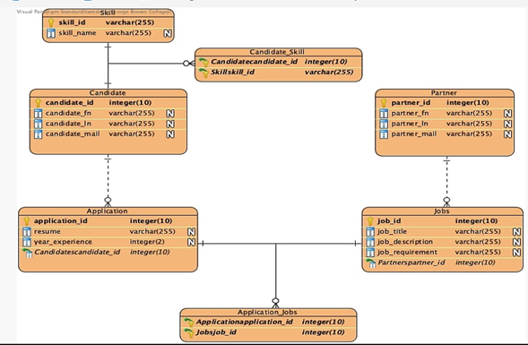

## 6.0 Other Requirements

The project must remain open ended and available for expansion as possible in case of JC Consulting wanting to add further features or details to existing features.

**7.0 Approval**

The signatures below indicate their approval of the contents of this document.

|  |  |  |  |
| --- | --- | --- | --- |
| Project Role | Name | Signature | Date |
| Project Supervisor | Tyler Krimmel |  |  |
| Project Supervisor | Anjana Shah |  |  |
| Project Lead | Chris Santin | Chris Santin | Nov. 5, 2018 |
| Team member | Duy Hao Bui | Duy Hao Bui | Nov 5, 2018 |
| Team member | Quan Trinh | Quan Trinh Trung | Nov 5, 2018 |
| Team member | Tam Dang | Tam Dang | Nov 5, 2018 |